**Best SEO Agency in Dubai**

At **RS Organisation**, we believe in delivering **proven SEO strategies** that transform businesses. As a leading **SEO Agency in Dubai**, we combine data-driven insights, technical expertise, and creativity to ensure long-term digital success. Our team specializes in **trusted SEO services in Dubai**, focusing on measurable results, ethical practices, and strategies that enhance visibility, traffic, and authority. Whether you’re a startup or an established enterprise, our customized solutions help you dominate search rankings and build sustainable growth. From **on-page SEO** to **backlinks** and **off-page SEO**, RS Organisation ensures your brand gets the recognition it deserves online.

**Drive Traffic, Leads, and Sales through Our Digital Modern SEO Services in Dubai**

Our mission goes beyond just rankings. At RS Organisation, we provide **modern SEO services in Dubai** that are designed to attract the right audience and convert them into paying customers. By aligning our strategies with the latest search engine algorithms, we maximize your online potential. With a balance of technical audits, keyword research, content optimization, and authoritative link-building, we not only increase visibility but also drive **consistent traffic, qualified leads, and higher sales**. Every campaign is backed by transparent reporting and ROI-driven strategies, ensuring your business scales effectively in a competitive digital marketplace.

**What Is the Role of SEO in Online Business in Dubai?**

In today’s digital-first economy, SEO is the backbone of online business success in Dubai. Without it, even the most innovative companies risk being invisible to their audience. **SEO Agency in Dubai** professionals, like RS Organisation, help businesses secure top rankings, build credibility, and reach customers actively searching for their services. SEO ensures you stay ahead of competitors by optimizing your site’s structure, performance, and content. Beyond rankings, SEO is about visibility, trust, and customer engagement. When executed correctly, SEO becomes a long-term asset that continuously drives new opportunities, sales, and brand reputation across diverse industries.

**How Do You Benefit from Affordable SEO Services in Dubai?**

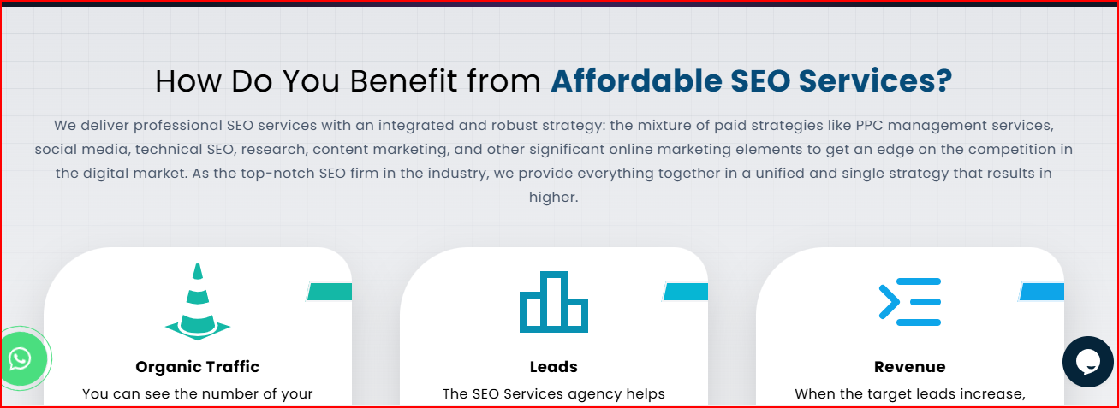

**Aisa wala Boxes Banega Link - https://www.imgglobalinfotech.com/seo-services.php**

**1. Organic Traffic**

Affordable SEO services increase **organic traffic** by optimizing your website for relevant keywords. Unlike paid ads, organic traffic is long-lasting and highly targeted. This ensures that your business consistently attracts qualified visitors genuinely interested in your products and services.

**2. Leads**

SEO drives high-quality leads by capturing search intent. Our strategies target users who are actively searching for solutions, which means they are more likely to convert into paying customers. This helps your business reduce dependency on cold outreach.

**3. Revenue**

With increased visibility and lead conversions, SEO directly contributes to revenue growth. A well-optimized website ensures that your business captures the right audience at the right time, boosting sales and creating a sustainable stream of income.

**4. Brand Awareness**

Effective SEO strategies improve **brand awareness** by ensuring your website appears on top of search results. The more frequently your brand is visible, the more trust and recognition you build among your target audience in Dubai.

**5. Business Growth**

SEO accelerates business growth by giving you a competitive edge in the digital marketplace. By consistently ranking higher for relevant keywords, your business gains more exposure, helping you scale operations, expand your reach, and grow sustainably.

**6. Authority and Trust**

Backed by authoritative **backlinks** and high-quality content, SEO positions your brand as a trusted leader in your industry. Search engines reward credible websites, and when users trust you, they are more likely to engage, purchase, and remain loyal.



**Why Choose RS Organisation for SEO Services?**

At RS Organisation, we don’t just deliver SEO—we deliver results. Our **SEO company in Dubai** is known for its **proven track record** of helping businesses achieve higher rankings, increased sales, and stronger digital authority. We specialize in both **on-page SEO** and **off-page SEO**, ensuring that your website not only ranks but also converts. Our team of experts stays updated with Google’s algorithm changes, providing strategies that are ethical, sustainable, and ROI-focused. With personalized solutions, transparent reporting, and measurable growth, we’ve earned the trust of clients across industries. Choose RS Organisation today and partner with the most reliable **SEO agency in Dubai** committed to your success.

Baaki Industries we serve

Our partner

Client work ka v section hoga https://www.rsorganisation.com/seo-company-in-dubai.html

